Image 1 Recorded image of you speaking, (if you are ok with that) after which you display the ECC logo/mission

AUDIO 1:

Hello, My name is Jonathan Marchand and I am a member of the Board of the Every Canadian Counts Coalition. I ask you to take 5 minutes to learn about our proposition to create a national publicly funded disability insurance program in Canada. We believe that it is only through such a system that the chronic issues of underfunding, inequity and the nightmarish administrative mess that is the current system can be addressed in Canada.
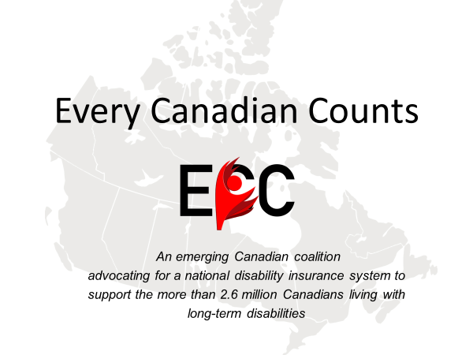

Image 2 Image

The Every Canadian Counts Coalition has been in existence for 5 years and has made extensive contacts across Canada and among the community of disabled persons, organizations, and those that care. Please stay with us us as we identify the problems and challenges of the current disability support system in Canada. This will be followed by a brief discussion on the insurance model and the principles and practices that make it work.
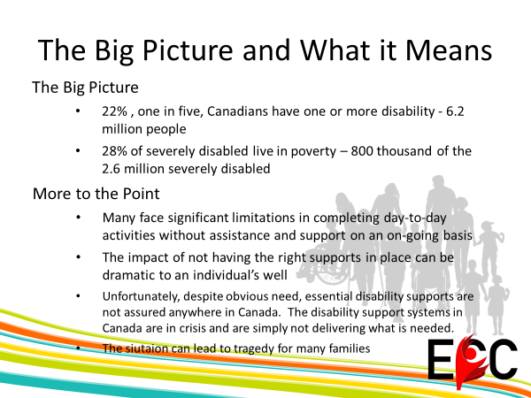

Image 4 [bullet points appear as script is read]]

There is no time available for us to get into the statistics other than to say that there is about 1 in 5 canadians over the age of 15 has one or more disabilities. That’s about 6.2 million people.

And about 2.6 millions are living with disabilities considered severe to very severe.

More to the point, basic supports, , things that allow Canadians with disabilities to live happier, healthier, fuller lives are not assured no matter where you live in Canada. Furthermore, the support systems are in crisis. They are simply not delivering what is needed.

This lack of proper support leads to all kinds of tragedies that you see in the media papers almost everyday. People with disabilities and their families are often marginalized, discriminated against, and very often lack the necessary support to be included in Canadian society.
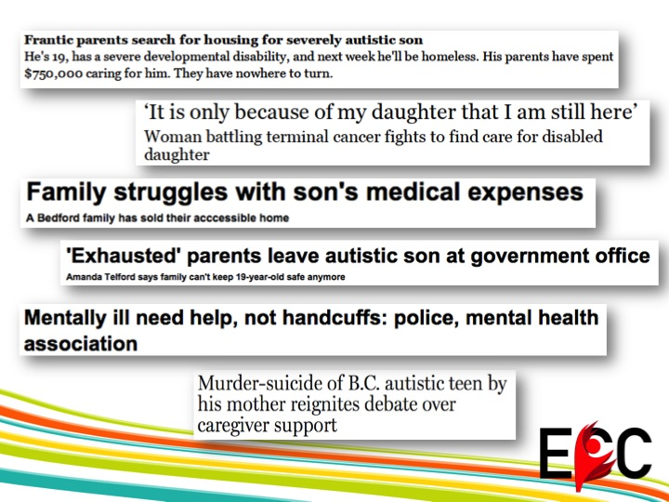

Image 5 [bullet points appear as script is read]

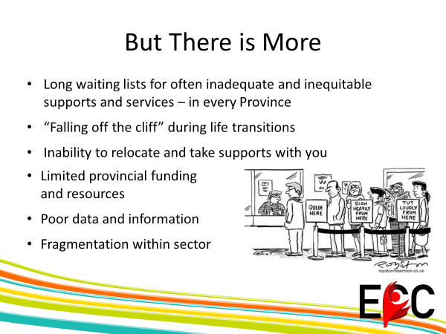

Image 3 Image

But there is more. And we can talk for a long time about the problems but to be brief there is the issue of difficulty of access to disability supports no matter where you live; every province and territory has long waiting lists for disability supports. There is “falling off the cliff”, those periods between youth and adulthood and adulthood and old age when many Canadians are forced to switch between government support programs.

There is the problem of immobility since our supports are provincially and territorially delivered, with no national standards, one loses supports should you move out of province. Provinces have been struggling to find resources while the incidence of disability has increased as our population age. Provincial governments are being asked to do more, with often less funding. Then there is the issue of inefficiencies.

As if that is not enough, our governments don’t communicate nor share information about what models of support they’re using and whether or not these are working. Canadians often don’t even know where to access supports.

Finally, there is massive fragmentation within the disability sector itself.

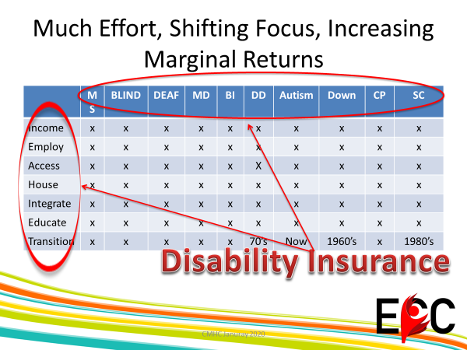
Image 6 [arrows and circles appear as script is read]

As can be seen in the table, everyone is working in their little boxes, all competing for resources and recognition. Then there is ‘the flavour of the month disability (bottom) where different decades highlight different conditions that get addressed – but only in part, and only for a while). It is a lottery as to who gets supports.

A disability insurance program will address all disabilities and all issues, and for all persons with disabilities in a much more efficient manner. We know that from the Australian experience which we urge you to review at ndis.gov.au

There is no reason for a country like Canada not to do this.

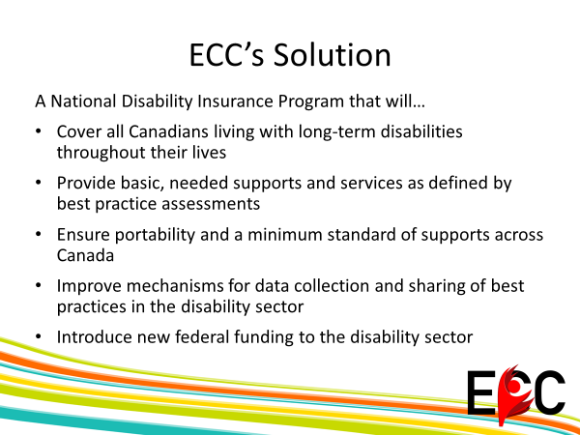

Image 7 [headline items appear as script is read]

What is the vision we see for such a support system? We would be aiming for a national disability program that would ensure all Canadians with long-term disabilities receive the essential supports and services they need over the course of their lifetimes. With a national scope it enables minimum standards to be set for support provision, which would then allow people to move between places without worry of losing supports. A national program could introduce new federal funding so our provinces and territories are better able to fund needed supports, as it is clear they cannot meet the demand.

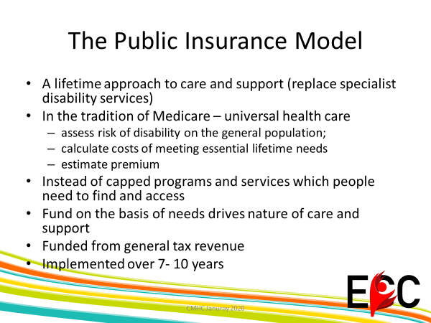
.
Image 8 [headline items appear as script is read]

In Canada the health support system (Medicare) is based on the universal principle that address individual needs, with services provided in the absence of a means tests. The same principles would govern disability insurance. The needs based person centered approach avoids one size fits all programming and fills the gaps in the current system. It would relieve families of the responsibility for care, particularly important for women who would be free to return to work. Experience elsewhere has shown it to be very affordable and financially much more manageable based on the full cost of supports over a person’s lifetime.

And the time is now. In the last five years the Federal government has committed more resources to address Disability Issues as evident with the passage of the Accessibility Act. The recent Throne speech has made reference to a policy of Inclusion and commitment to a Disability Benefit. We believe at ECCC that it is to the federal government that we should turn our sights and that a nationally sponsored publicly funded disability insurance supports system should be the objective of our concerns and activism.

Thank you very much, you can reach us at everycanadiancounts.com and follow us on facebook and twitter.

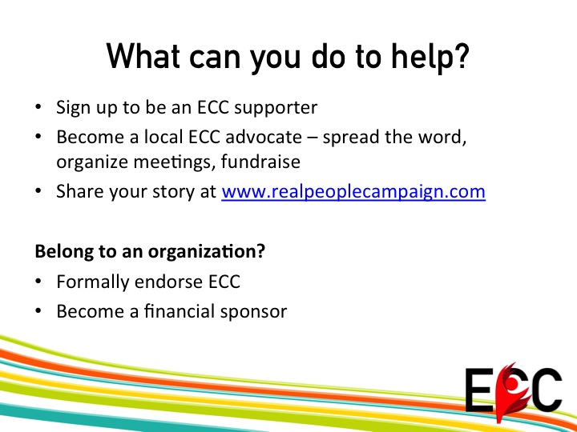

Image 9 [bullets appear as script is read]

Image 10 [final image before copyright/credits]

